The Child Abuse Prevention Coordinating Council of Humboldt County (CAPCC) is a broad-based, nonprofit advocacy organization that works to eliminate child abuse and neglect in our community through (1) striving to assure coordinated services and policies for the prevention, intervention and treatment of child abuse among agencies and organizations, (2) actively promoting and supporting high-quality programs that successfully reduce child abuse and neglect and (3) increasing public awareness of resources to help prevent child abuse and decrease family stress. Our Mission is:

Strengthening community connections to promote safe, healthy, resilient children and families in Humboldt.

ACAPCC continues to participate in the Cross-Sector Collaborative of the Family First Prevention Services Act (FFPSA) which has expanded referrals and service delivery through Community Pathways sites throughout Humboldt County. The ultimate goal of strengthening and expanding the work of Family Resource Centers and other community pathway sites is to reduce the number of children taken into foster care. However, we realize that it may take several years to see a clear impact in those numbers. Right now we can say that referrals for nearly all categories of services offered by these sites have continuously increased since we began collecting consistent data in July 2024.

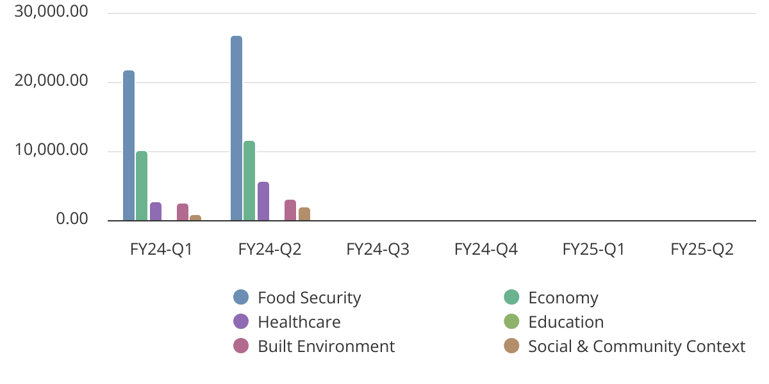
Figure 1. Number of referrals to general services made by Community Pathway sites
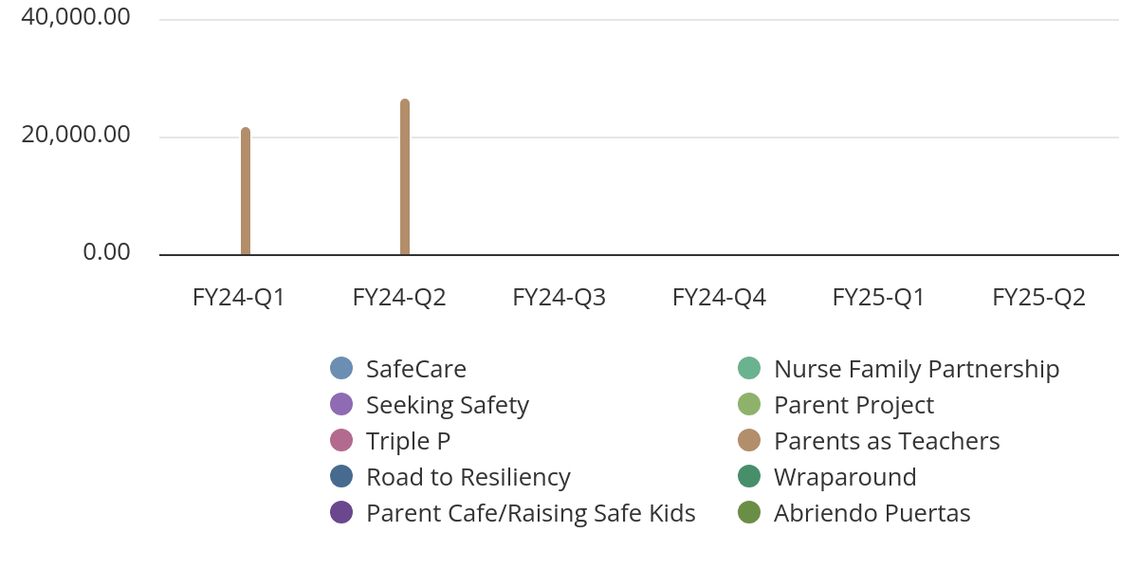
Figure 2. Number of referrals to evidence-based practices made by Community Pathway sites

CAPCC will continue to support FRCs as important sources of family support across our widespread rural geography. In July 2024, CAPCC supported the inclusion of a bill in the reauthorization of Title IV-B, which would establish Family Resource Centers as a federally defined entity. As of December last year, it was making committee rounds, and we believe its passage will enable greater federal support of FRCs and their crucial work in our communities.

CAPCC participated in the 2024 Statewide Prevention Convening (FFPSA). This gathering has proven to be an excellent source of support and sharing of experiences for the agencies that are involved in implementing their Comprehensive Prevention Plans, addressing such issues as sustainable financing, meaningful community involvement, and relationship-based leadership vs. compliance-based service delivery. Cindy Sutcliffe and Megan Gotcher presented, with two other people from County Probation Department, a discussion entitled, “Unique Approaches to Family First Prevention Services Programs with Real Impact in Rural Communities”.

CAPCC is currently participating in a process – in partnership with Live Well Humboldt - of mapping its member’s programs that support CHIP strategies in the Healthy Beginnings/ACEs priority area. Our member organizations are delivering family strengthening, parenting education and support, children’s mental health care and reduction of family stressors, and support of foster youth -- all of which contribute to the reduction of adverse childhood experiences that can result in such debilitating health conditions as substance use disorders, mental and physical illness, and involvement in the criminal justice system. We are currently working with Public Health’s Live Well Humboldt initiative to develop measurable outcomes by which our collective impact can be assessed and reflected in their upcoming Community Health Assessment.

Last year we reported to you that we were participating in a state-wide reconsideration of mandated reporter regulations. We conducted a small survey of mandated reporters here in Humboldt in 2023-24. Our goal was to gather specific information about what kind of training programs mandated reporters are required to take in different professions. Our report on the data we collected and the recommendations we will be making to the State Taskforce on Mandated Reporting is under review with our Board Members and will be submitted to the Board of Supervisors within the coming week. The main take-away from our survey is that training quality, frequency of administration, and extent of information imparted should be made consistent across the state. The report examines additional considerations in reforming the mandated reporter training process in California.

CAPCC celebrated the passage of recent legislation (2023) that revised the definition of general neglect to exclude a parent’s economic disadvantage from consideration of harm. Research has suggested that across professions, there is a very poor understanding of the meaning of severe neglect which the MR law was originally intended to address and often reports of neglect are made for conditions that could and should be addressed by community support programs. CAPCC of Humboldt agrees that poverty is not a legitimate element of neglect for the purposes of removing children from their family.

CAPCC has been unable to find a feasible solution for promoting the Child Protection Reporting Guide (CPRG) that was created as a result of the Attorney General’s stipulations to Humboldt County CWS. The stumbling block has been a lack of funding to support the community education and training required to have it become widely known and trusted as a reliable decision-making system. We are now considering how a volunteer effort may be organized to establish the CPRG as a community resource. We believe the CPRG provides the best foundation for making informed decisions in reporting child abuse and neglect and can be of great service in operationalizing the philosophical shift toward more Community Supporting than Mandated Reporting.

In 2024 our Service Provider Roundtable Event took place in May, with the theme of Centering Our Families. 120 people registered, and 94 attendees participated. A total of 25 local service organizations tabled at the event. Increasingly, organizations are advising or requiring greater participation in governance by persons with lived expertise. Our panels and keynote talk were designed to lift up the value of recruiting people with lived expertise to participate in guiding or governing systems that serve people like themselves. A number of our panelists had both personal experience and work competence – and often professional training as well – and illuminated the insights as well as some of the quandaries of working in a field that had once served them or their family members. A majority of the attendees ranked the conference presentations highly and some came forward and expressed an interest in working with our Board.

During April 2024, which is Child Abuse Prevention Month, CAPCC accomplished the following:

- Accepted a proclamation from the Board of Supervisors on April 9th.
- Arranged for street banners to be hung in Eureka and Arcata.
- Published a Spring e-newsletter in Spanish, English, and Hmong, distributed via email throughout our membership, posted on our website and our Facebook page.
- Broadcast a 60-second radio spot highlighting April as Child Abuse Prevention Month on local radio stations.
- Provided a 15-minute interview on our Spanish-only radio station highlighting April as Child Abuse Prevention Month and the work that CAPCC is doing in the community.
- Arranged for the children’s memorial flag raising to occur on the 4th Friday of April at the Eureka Boys & Girls Club Teen Center.
- Recognized the outstanding work of youth leaders of IPA School-Based Wellness Centers, Child and Family Services Specialist Carolyn Albee, Parent Educator Haydee Hopkins and Officer Jayme Clark as recipients of our 2024 Children First awards. We posted their accomplishments to reduce or prevent child abuse on our Facebook page.
- Organized several pinwheel parades in April to coincide with our promotion of the Child Abuse prevention theme, traditionally led by College of the Redwoods Child Development Center and participated in several childcare sites in Eureka and Arcata (see photo of CR group below).

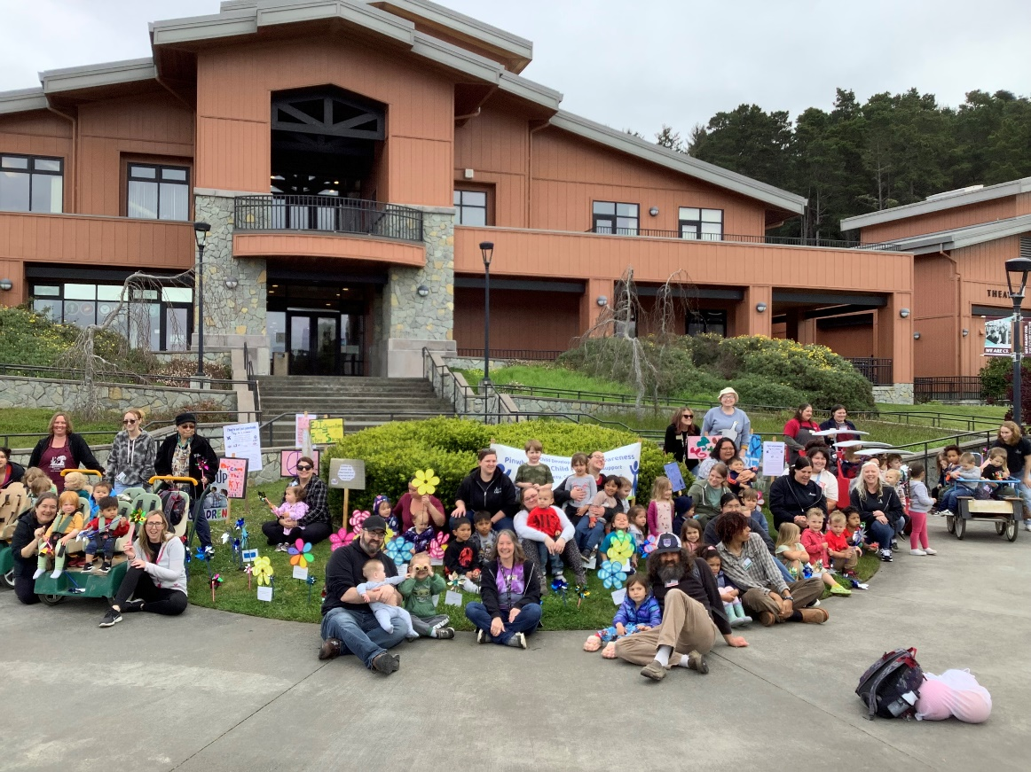

Also in 2024, CAPCC Board Members participated in a Strategic Planning session that reviewed our self-assessment to consider what areas of our work warrant improvement. We determined that renewed energy would be directed to expand our membership and recruitment, with a specific focus on youth and parents with lived expertise in the systems of family support and foster care toward which our policies are focused. We will be developing educational materials to better communicate the programs CAPCC champions and to build greater community awareness of the family support structures we promote in the Comprehensive Prevention Plan.

CAPCC maintained a presence at a number of community events throughout the year, including the Redwood Coast Mental Health Symposium and a conference on Murdered and Missing Indian Persons, both last May, the Juneteenth celebration in Eureka, and others. We continue to share, through our newsletters, Facebook posts, and our website, regional training opportunities, child vaccination clinic schedules, and family-supporting activities not only in April but also throughout the year. We appreciate the opportunity to report on our work.

Respectfully submitted,

Jan Bramlett, President
Child Abuse Prevention Coordinating Council of Humboldt

Attachment:

Shifting From Reporting Families to Supporting Families: California’s Mandated Reporting to Community Supporting Task Force and Recommendations (Summary), September 2024.

Note: All of the services reflected in these charts receive referrals from other programs. These two charts reflect only those that are recorded by the FRCs, four Tribal resource centers and HCTAYC as part of the FFPSA project.
H.R.8798, the Promoting Community Based Prevention Services Act

